ENERGIZING FUTURE ENGINEERS

One of the most enduring traditions on the Evansdale campus of West Virginia University (WVU) is the annual Pumpkin Drop competition. In every late October for the past 30 years, large crowds of elementary, middle, and high school students accompanied by friends, teachers and guardians gather around the 11 story Engineering Sciences Building (ESB) to watch hundreds of pumpkins, each weighing about 60 pounds, fall from its roof, hopefully not to their doom. The atmosphere on the ground brings to mind a country fair, but with an engineering twist. On one side, there are plenty of opportunities for fun and entertainment, such as enjoying a climb into a fire truck, playing ball on the grass, or just munching on hot dogs and chili. On the other side, the visitors can get a close look at modern technology and engineering “marvels” by watching a robot roaming the lawn, race cars and other vehicles designed and built by engineering students, including Unmanned Aerial Vehicles (UAV’s). The grounds are teaming with students waiting for the turn of their pumpkin to face the challenge, while at the same time many of them use the opportunity to take a glimpse at STEM (Science, Technology, Engineering, Mathematics) education by conversing with engineering students and faculty or touring open laboratory, shop and classroom facilities inside the ESB.

The challenge is simple to explain. Winners in the competition must develop contraptions which allow their pumpkins to survive intact the eleven stories fall and land close to a target marked on the ground. The surviving pumpkin that lands closest to the target is considered to be the winner. The event allows the students to gain valuable practical knowledge by designing and building their contraption throughout the year, while enjoying the thrill of the competition and working together as a team. At the start of the last round of the competition, a special plaque of recognition was handed to Dr. Wally Venable, an Emeritus Professor in the MAE department, who has consistently volunteered to serve as the main judge in each and every one of the 30 years in which we have hosted the annual Pumpkin Drop. The control of the competition was then assumed by Dr. Darran Cairns, an Adjunct Professor in the MAE department, who has served as “Master of Ceremonies” for the last nine years, and has traveled from Kansas especially for this purpose at his own expense.

The winner of the 30th Annual Pumpkin Drop competition was a team from the Greater Beckley Christian School in Prosperity, West Virginia, whose pumpkin landed only 2’4” from the target. The Yough High School team from Herminie, Pennsylvania, took second place with their pumpkin landing 2’9” away from the target. The third place went to the East Fairmont Middle School, whose pumpkin landed 3’2” from the target. Overall, the 30th annual Pumpkin Drop was a great success, facilitated by a sunny autumn day, with over one hundred pumpkins surviving the challenge. The competition was hosted and overseen as in each of the previous 29 years, by staff and students from the Department of Mechanical and Aerospace Engineering (MAE) in WVU’s Statler College of Engineering and Mineral Resources. In particular, members of the local student chapter of the American Society of Mechanical Engineers (ASME), have volunteered to guide the visitors through the premises, maintain all activities in proper order, and watch for strict enforcement of safety rules at all stages. They have raised an amount of $3870 for their annual donation to the Ronald McDonald House, which shelters families of ill children who are treated at the WVU Hospital. Fund raising for such donation has been from the outset the main scope of the MAE staff and students for hosting this annual competition and planning it throughout the year.

Over the past decade, the Pumpkin Drop event has grown steadily from year to year, from a little over 100 to almost 400 entries in 2017 (see graph below), or by 288% over the past eight years. The large number of teams signed up for the opportunity to splutter the front yard of the ESB with orange guts should be enviable by many other organizers of student competitions. The popularity of our event is especially extraordinary when we consider the long distances and times that many teams have to travel on the day of the competition from their own locations to Morganton, as illustrated in the following map by the home sites of the teams from West Virginia, Pennsylvania and Ohio that participated this year in the event. The longest distances were traveled by teams from Point Pleasant, Charlestown, and Prosperity, WV, at about 169 to 171 miles and nearly 3 hours of driving one way in their school buses.

The Pumpkin Drop competition started with an idea proposed at a meeting of the local student chapter of the American Society of Mechanical Engineers (ASME) by Mark Reeder, then an undergraduate student in mechanical engineering, and now a professor at the U.S. Air Force Institute of Technology and member of the Academy of Distinguished Alumni of the department of Mechanical and Aerospace Engineering (MAE). While eggs have been traditionally used in similar challenges, Mark has proposed at the time to replace them with pumpkins. As one could have expected, only a few college students have participated in the first Pumpkin Drop, but even then the event was covered by our local newspaper. Even at that time, it was apparent to many that this competition was very likely to grow and become a special attraction for students of all ages in the surrounding region. As the Pumpkin Drop competition has reached the 30-year mark, its continuing success and steady growth in popularity must be credited not only to the support received from succeeding administrations at the department, college and university levels, but also to the commitment and perseverance of the local student chapter of ASME, whose members have consistently overseen the safety and effectiveness of all activities, have prepared and worked at the food concessions. While many generations of students have succeeded in this undertaking, Dr. John Kuhlman has served as the faculty advisor of the local ASME chapter throughout this period until his recent retirement last summer when this responsibility was taken over by Dr. Scott Wayne.

Special recognition is fully deserved by key members of the MAE technical and administrative staff, who have mastered over the years all the communications and the logistical arrangements that are essential for planning, executing and managing the annual WVU Pumpkin Drop in an efficient and safe manner. For example, during the last decade all the preparations for the event and its safe, efficient execution have been coordinated by the Office Manager of the MAE department, Ms. Pat Goldie, who was assisted by Ms. Kande Brandt in the last couple of years. They made sure that all teams of visiting students are allowed to move smoothly through the campus, so that they are able to drop their pumpkins within the preassigned hour, and the team members from every school could return home on time, as scheduled in advance. On the day of the competition, the coordination and oversight responsibilities of the MAE staff extend over all the related activities and participants, including registration, parking, university police, food concessions, ASME team, rooftop and ground safety, equipment and accessories. Another MAE staff member who has assumed an important role in the preparations leading to this event and in carrying it out safely is Mr. Kelsey Crawford, who pushed all the pumpkins off the roof of the ESB by using a specially designed board and with the assistance of his team of student workers. As the result of the effective organization of the event and our hospitality on the WVU campus, visiting team advisors, school teachers, administrators, and bus drivers, and not just competing students, are eager to come back and take part in the Pumpkin Drop event year after year.

The annual Pumpkin Drop competition is not only a challenge for the participating teams, but also an excellent public relations and student recruitment opportunity for WVU and the Statler College in general, and the MAE Department in particular, where we can showcase highlights of our educational programs, cutting edge research, modern facilities, and a variety of social and professional extracurricular activities for our students. As we applaud the members of the local ASME student chapter and the MAE administrative staff, and especially Ms. Goldie and Ms. Brandt, who have contributed to planning and hosting yet another successful event, we are confident that this tradition will carry on for the next 30 years with even more teams from near and far away, who will be attracted to participate in the Pumpkin Drop competition for fun, challenge, and a great opportunity to be introduced to WVU, the Statler College, and the MAE Department.

List of Winning Teams in the Last Five Years:

|  |  |  |  |  |  |
| --- | --- | --- | --- | --- | --- |
|  | 2013 | 2014 | 2015 | 2016 | 2017 |
| 1st Place | Suncrest MS, Morgantown, WV (4”) | Frankfort HS, Ridgeley, WV (6”) | Wheeling Catholic Central HS , Wheeling, WV (3’7”) | Mountaineer MS, Morgantown, WV (2’1”) | Greater Beckley Christian School, Prosperity, WV (2’4”) |
| 2nd Place | Morgantown HS, Morgantown, WV (11”) | Suncrest MS, Morgantown, WV (1’) | Triadelphia Area Rapid Descent Impact Solutions (4’2”) | Gilmor Co. HS, Glenville, WV (2’11”) | Yough HS, Herminie, PA (2’9”) |
| 3rd Place | Suncrest MS, Morgantown, WV  (1’11”) | Feed My Sheep Christian School, Philippi, WV  (1’5”) | South MS, Morgantown, WV (4’3”) | Fairmont MS, Fairmont, WV (3’) | East Fairmont MS, Fairmont, WV (3’2”) |

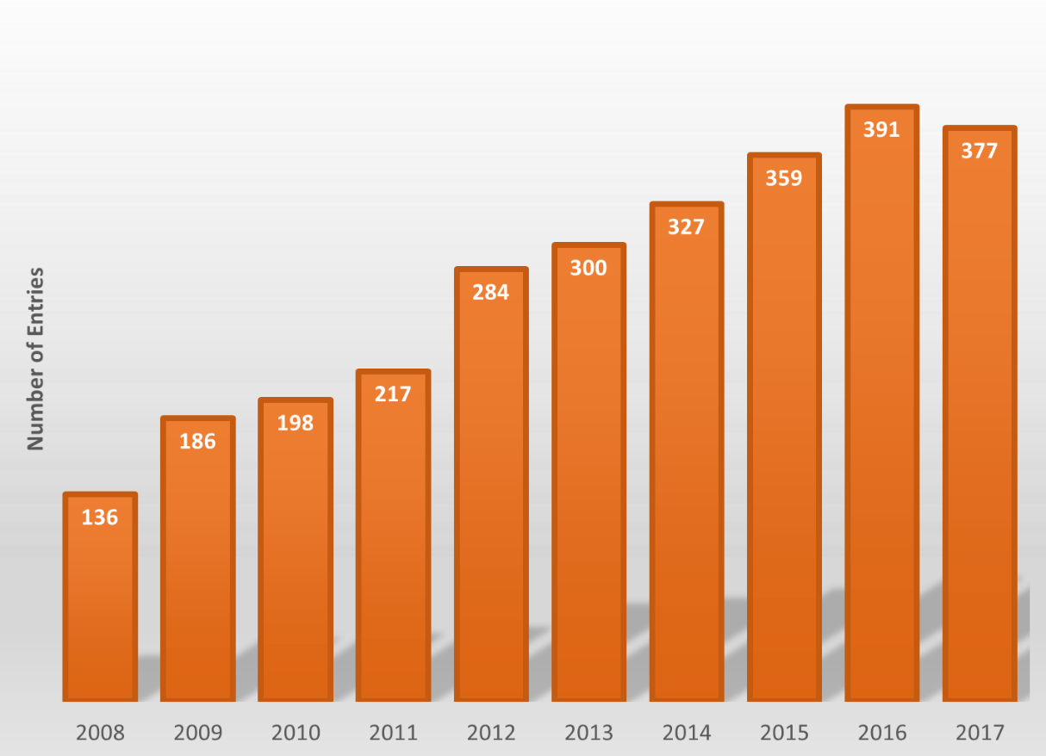

Number of teams participating in the annual Pumpkin Drop Competition from 2008 to 2016.



Map of home location of teams participating in the 2016 WVU Pumpkin Drop.

